Assignment -1

Python Programming

|  |  |
| --- | --- |
| Assignment Date | 19 September 2022 |
| Student Name | KAUSHIK.S |
| Student Roll Number | 311019106027 |
| Maximum Marks | 2 Marks |

Question-1:

Write a program which will find all such numbers which are divisible by 7 but are not a multiple of 5, between 2000 and 3200 (both included). The numbers obtained should be printed in a comma- separated sequence on a single line.

|  |
| --- |
| **Solution:** |
| l=[] |
| for i in range(2000, 3201): |
| if (i%7==0) and (i%5!=0): |
| l.append(str(i)) |
| print (','.join(l)) |
| # # |
| # # |

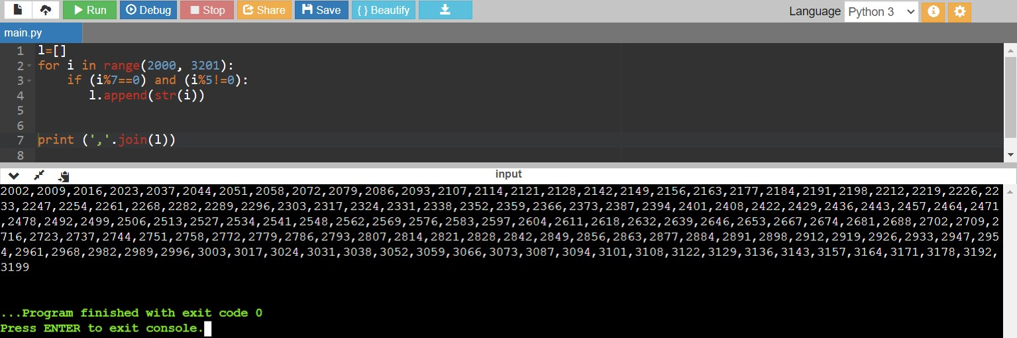

Question-2:

Withagivenintegralnumbern,writeaprogramtogenerateadictionarythatcontains(i,i*i)suchthat is an integral number between 1 and n (both included). and then the program should print the dictionary.

Suppose the following input is supplied to the program: 8

Then, the output should be:

{1:1,2:4,3:9,4:16,5:25,6:36,7:49,8:64}

|  |
| --- |
| **Solution:** |
| n=int(input()) |
| d=dict() |
| for i in range(1,n+1): |
| d[i]=i*i |
| print d |
| # # |
| # # |

